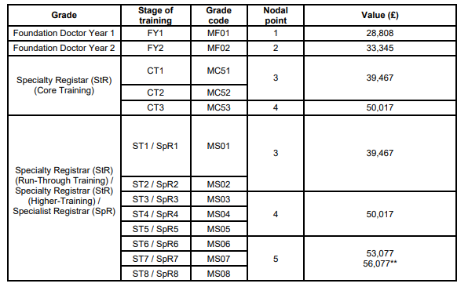

The above document details the pay progression and Nodal points for trainee medics. When using this in conjunction with ESR and pay the prefix MT is replaced by MF/S although remains the same in terms of value etc. Nodal point progression is based upon years’ service and completed Annual Review of Competence Progression (ACRP)

Further information relating to ARCP can be found at the following link, <https://foundationprogramme.nhs.uk/curriculum/arcp/>